14.68: a) See problem 14.67. Replacing f with, respectively, 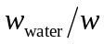and 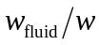 gives

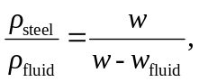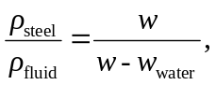

and dividing the second of these by the first gives

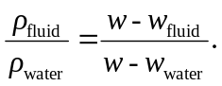

b) When 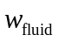is greater than 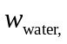 the term on the right in the above expression is less than one, indicating that the fluids is less dense than water, and this is consistent with the buoyant force when suspended in liquid being less than that when suspended in water. If the density of the fluid is the same as that of water 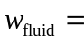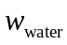, as expected. Similarly, if is less than , the term on the right in the above expression is greater than one, indicating the the fluid is denser than water. c) Writing the result of part (a) as

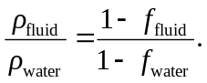

and solving for 